Liceo Bicentenario
NAME: __________________________________
GRADE: 1°__________________________

Héroes de la Concepción - Laja

UNIT 0 – WORKSHEET 2
LEARNING OUTCOMES: Identify and use vocabulary related to daily routine. Ask for and give personal information.

DAILY ROUTINE: PRESENT SIMPLE
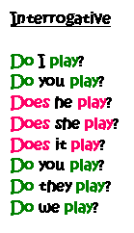
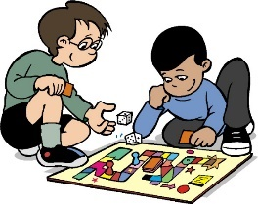
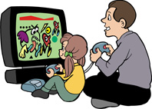

get up have lunch get dressed not/ watch TV
walk to school take a shower feed the dog go shopping
cook the dinner do housework wash the dishes ride a bicycle
not/brush teeth play football not/do homework chat online

Instructions: Use the words above in their correct form to complete the sentences below.

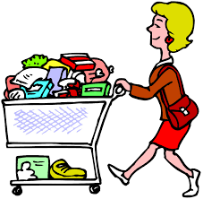
- My Parents usually ____________________ on the weekend. They buy everything they need.
- Juan _______________ for the school before breakfast. He wears trousers and a t-shirt.
- My sister and I ________ every Sunday. I usually sweeps the floor and she dusts the furniture.
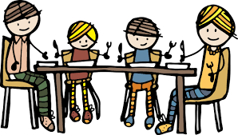
- Alexis _____________ every morning between 5:00 and 6:00 p.m. She loves cycling.
- Every day at 1:00pm I __________________ at home with my family.
- Valentina ________ her teeth three times a day
- When I _________________ my teacher gets angry with me.
- Lider ____________________ for 30 minutes in his bathroom every afternoon.
- My Uncle ________________ before he goes to work every morning.
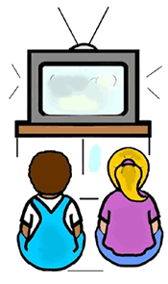
- We have to ___________________________ after breakfast or our dad gets mad.
- During the week the children______________________.
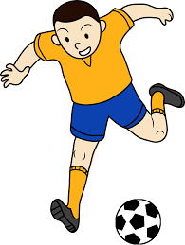
- I always ______________ early in the morning because I have to be at school by 6:20am.
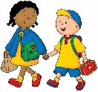
- Vick__________________ with his friends every Tuesdays.
- Most of my classmates ________________ every day because they live very close to school.
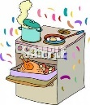
- My students _______________ for 4 hour with their friends every day.
- My grandma never ___________________ on the weekend.

ASKING AND ANSWERING QUESTIONS
ersonal

- Match the questions with the answers below. (Escribe el número de la pregunta en la respuesta correspondiente)
nformation

v
What time do you go to bed?
What do you usually have for dinner?
When do you do your homework?
Where do you have lunch?
How do you go to school?
What do you have for breakfast?
Who is your favorite singer?
What are your hobbies?
What time do you get up?
What colour are your eyes?
What is your favorite subject?
What is your hair like?
When is your birthday?
When were you born?
How many brothers and sisters have you got?
What is your address?
What is your nationality?
Where are you from?
How old are you?
What is your name?

14 At 7 am.
____ 6th Avenue.
____ France.
____ Green.
____ It’s Lady Gaga
____ It’s short.
____ At home.
____ It’s Mike.
____ Painting.
____ 12.
____ In 2010.
____ Italian.
____By bus.
____ At 10 pm.
____ In the afternoon.
____ May 3rd.
____ I’ve got one brother.
____ History.
____ Milk and bread.
____ Soup.

12. _________________________________
13._________________________________
14. _________________________________
15. _________________________________
16. _________________________________
17._________________________________
18. _________________________________
19. _________________________________
20. _________________________________
- __________________________________________
- __________________________________________
- __________________________________________
4. _______________________________________
5. _______________________________________
6. _______________________________________
7. _______________________________________
8. _______________________________________
10. ______________________________________
11. ______________________________________

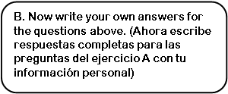
B. Now write your own answers for the questions above. (Ahora escribe respuestas completas para las preguntas del ejercicio A con tu información personal)

