UNIT 1 - 2º MEDIO: Globalization and Communication
NAME: | DATE: | CLASS:
LEARNING OUTCOME:
- OA 16 Demostrar conocimiento y uso del lenguaje en sus textos escritos por medio de las siguientes funciones:
- Describir acciones que comenzaron en el pasado y que aún continúan o acaban de finalizar; por ejemplo: We have been training for three months; she has been working all day.

GRAMMAR:
HOW LONG & PRESENT PERFECT CONTINUOUS
HOW LONG HAVE YOU…?: ¿POR CUÁNTO TIEMPO HAS TÚ….?

FOR: POR / DURANTE
SINCE: DESDE

- EJEMPLO:

Q: HOW LONG HAVE YOU BEEN STUDYING ENGLISH?
P: ¿POR CUÁNTO TIEMPO HAS ESTADO ESTUDIANDO INGLÉS?

A: I HAVE BEEN STUDYING ENGLISH FOR 10 YEARS.
I HAVE BEEN STUDYING ENGLISH SINCE 2010.

R: YO HE ESTADO ESTUDIANDO INGLÉS POR 10 AÑOS.
YO HE ESTADO ESTUDIANDO INGLÉS DESDE 2010.

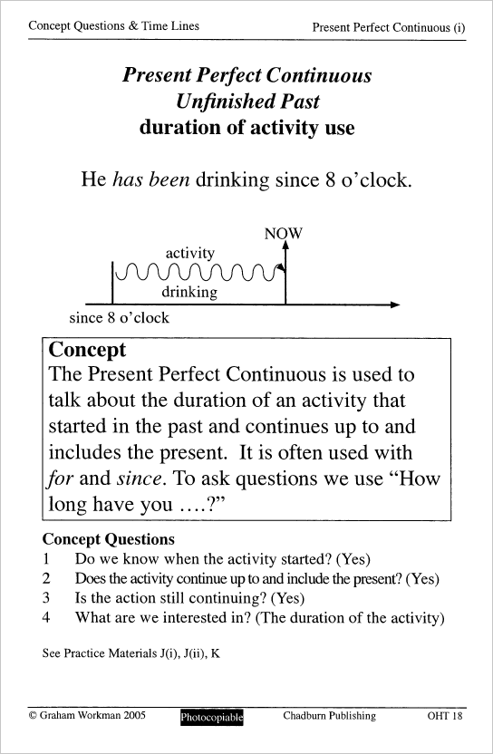

GRAMMAR PRACTICE
1. Create appropriate questions for the following answers. Crea preguntas apropiadas para las siguientes respuestas.
Example:
- How long have you been talking on the phone?
I have been talking on the phone since 3:00 pm.

- _________________________________________________________________________________ ?
The nanny has been cleaning the room for 2 hours.
- _________________________________________________________________________________?
We have been eating Mexican food since last week.

- _________________________________________________________________________________ ?
They have been dating for 4 months.

- _________________________________________________________________________________ ?
I have been studying since 8:00 am.

- _________________________________________________________________________________ ?
It has been snowing for a long time.

2. Read the following situations. What have they been doing? Lee las situaciones. ¿Qué han estado haciendo? Usa Since o For en tus repuestas.
Example:
- I started reading 30 minutes ago and I am still doing it.
I have been reading for 1 hour.

- We arrived here 1 hour ago and we are still waiting.
__________________________________________________________________________________
- Samantha started acting when she was 5 years old and she still does it.
__________________________________________________________________________________
- My friend started doing the test at 9:45 and he’s still doing it.
__________________________________________________________________________________
- The band started playing ½ hour ago and they are still playing.
__________________________________________________________________________________
- The dog started barking 20 minutes ago and it’s still barking.
__________________________________________________________________________________
- Carlos and Diana started dating 6 months ago and they are still together.
__________________________________________________________________________________
3. Answer the following questions with information about you. Use complete Present Perfect Continuous sentences. Responde las preguntas con información acerca de ti. Usa oraciones completas en el Presente Perfecto Continuo.

- What song have you been listening to a lot recently?
_____________________________________________________________________________________
- What have you been thinking about today?
_____________________________________________________________________________________
- What clothes have you been wearing a lot lately?
_____________________________________________________________________________________
- How long have you been studying at this school?
_____________________________________________________________________________________
- Where have you been going on weekends?
_____________________________________________________________________________________
- How long have you been talking to your best friend?
_____________________________________________________________________________________
4. Write sentences in the Present Perfect Continuous with the given information. You need to add a complement and since or for. Escribe oraciones en el Presente Perfecto Continuo con la información dada. Necesitas agregar un complemento y since o for.

Example:
(+) I have been teaching English for 7 years.
(I / teach / 7 years)
- (+) ______________________________________________________________________________________________________ (You / read / 10 minutes)
- (-)______________________________________________________________________________________________________
(Charles / sleep / last week)
- (+)______________________________________________________________________________________________________
(My friends / watch / 3 hours)
- (-)______________________________________________________________________________________________________
(We / buy / last year)
- (+)______________________________________________________________________________________________________
(She / paint / Friday)

